**Exercise 1: Control Structures**

**Scenario 1:**

CREATE TABLE customers (

    customer_id NUMBER PRIMARY KEY,

    name VARCHAR2(50),

    age NUMBER,

    balance NUMBER,

    isVIP VARCHAR2(5),

    loan_id NUMBER

);

CREATE TABLE loans (

    loan_id NUMBER PRIMARY KEY,

    customer_id NUMBER,

    interest_rate NUMBER,

    due_date DATE

);

INSERT INTO customers VALUES (1, 'John', 65, 15000, 'FALSE', 101);

INSERT INTO customers VALUES (2, 'Alice', 45, 8000, 'FALSE', 102);

INSERT INTO customers VALUES (3, 'Bob', 70, 12000, 'FALSE', 103);

INSERT INTO customers VALUES (4, 'Clara', 30, 20000, 'FALSE', 104);

INSERT INTO loans VALUES (101, 1, 8.5, SYSDATE + 10);

INSERT INTO loans VALUES (102, 2, 9.0, SYSDATE + 40);

INSERT INTO loans VALUES (103, 3, 7.5, SYSDATE + 5);

INSERT INTO loans VALUES (104, 4, 10.0, SYSDATE + 25);

COMMIT;

BEGIN

    FOR cust IN (

        SELECT customer_id, age, loan_id

        FROM customers

        WHERE age > 60

    ) LOOP

        UPDATE loans

        SET interest_rate = interest_rate - 1

        WHERE loan_id = cust.loan_id;

        DBMS_OUTPUT.PUT_LINE('Discount applied for Customer ID: ' || cust.customer_id);

    END LOOP;

END;

**OUTPUT:**

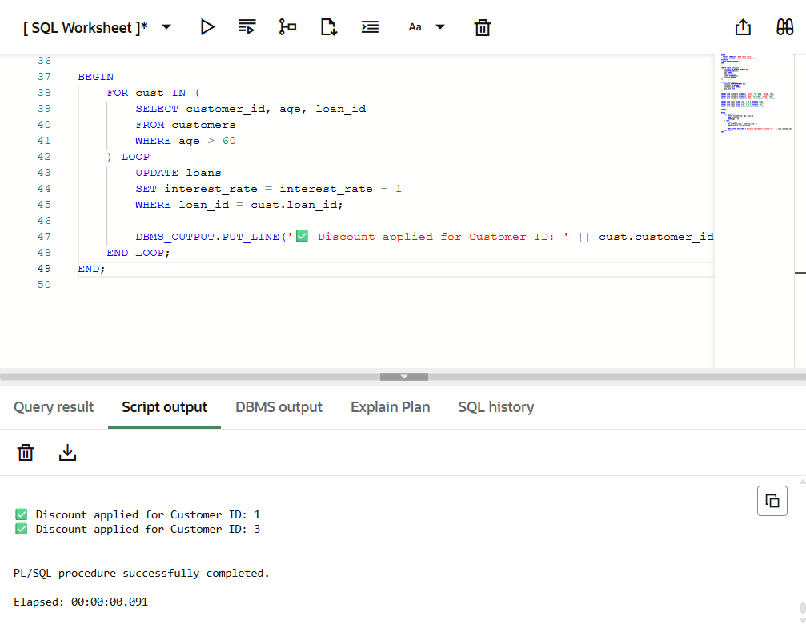

**Scenario 2:**

BEGIN

    FOR cust IN (

        SELECT customer_id, balance

        FROM customers

        WHERE balance > 10000

    ) LOOP

        UPDATE customers

        SET isVIP = 'TRUE'

        WHERE customer_id = cust.customer_id;

        DBMS_OUTPUT.PUT_LINE('Customer ID ' || cust.customer_id || ' is now VIP');

    END LOOP;

END;

**OUTPUT:**

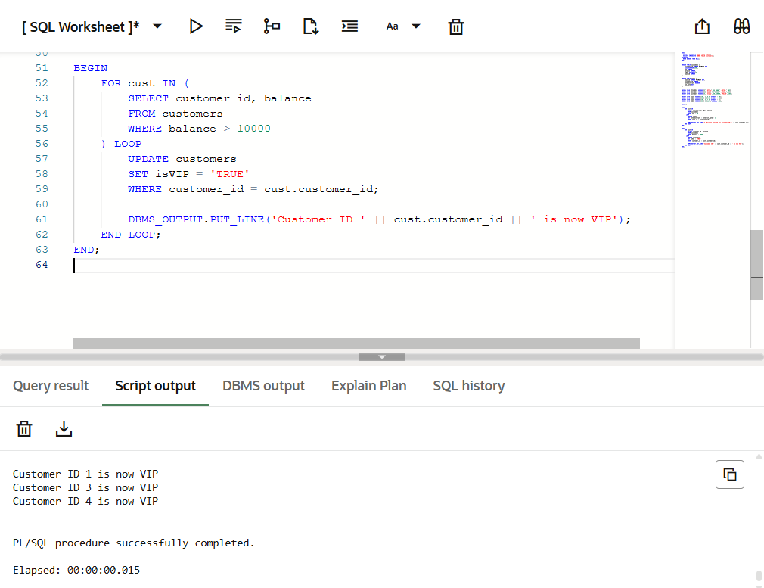

**Scenario 3:**

BEGIN

    FOR loan_rec IN (

        SELECT l.loan_id, l.due_date, c.customer_id, c.name

        FROM loans l

        JOIN customers c ON l.customer_id = c.customer_id

        WHERE l.due_date BETWEEN SYSDATE AND SYSDATE + 30

    ) LOOP

        DBMS_OUTPUT.PUT_LINE('Reminder: Loan ID ' || loan_rec.loan_id ||

                             ' for ' || loan_rec.name ||

                             ' is due on ' || TO_CHAR(loan_rec.due_date, 'DD-MON-YYYY'));

    END LOOP;

END;

**OUTPUT:**

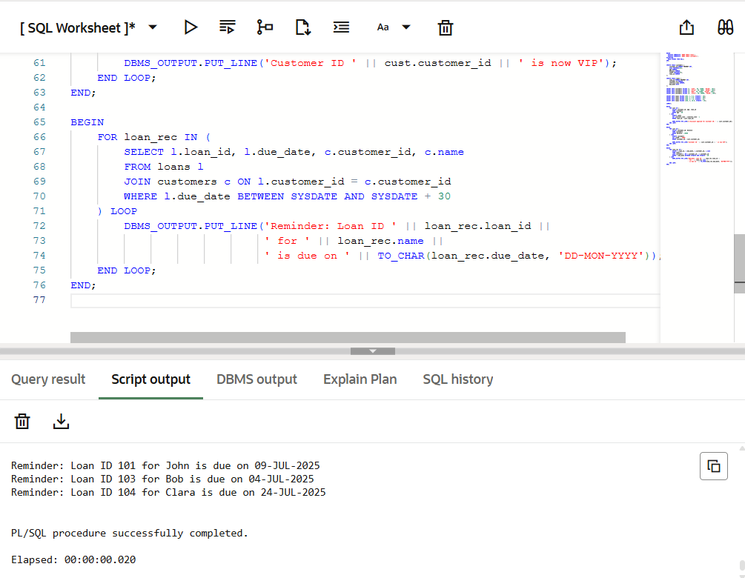

**Exercise 3: Stored Procedures**

**Scenario 1:**

CREATE TABLE accounts (

    acc_id NUMBER PRIMARY KEY,

    cust_name VARCHAR2(50),

    acc_type VARCHAR2(20),

    balance NUMBER

);

CREATE TABLE employees (

    emp_id NUMBER PRIMARY KEY,

    emp_name VARCHAR2(50),

    department VARCHAR2(30),

    salary NUMBER

);

INSERT INTO accounts VALUES (1, 'John', 'savings', 10000);

INSERT INTO accounts VALUES (2, 'Alice', 'current', 8000);

INSERT INTO accounts VALUES (3, 'Bob', 'savings', 15000);

INSERT INTO accounts VALUES (4, 'Clara', 'savings', 12000);

INSERT INTO employees VALUES (101, 'Emma', 'HR', 50000);

INSERT INTO employees VALUES (102, 'Liam', 'Sales', 60000);

INSERT INTO employees VALUES (103, 'Olivia', 'Sales', 58000);

COMMIT;

CREATE OR REPLACE PROCEDURE ProcessMonthlyInterest IS

BEGIN

    FOR acc IN (

        SELECT acc_id, balance

        FROM accounts

        WHERE acc_type = 'savings'

    ) LOOP

        UPDATE accounts

        SET balance = balance + (balance * 0.01)

        WHERE acc_id = acc.acc_id;

        DBMS_OUTPUT.PUT_LINE('✅ Interest added to Account ID: ' || acc.acc_id);

    END LOOP;

END;

/

BEGIN

    ProcessMonthlyInterest;

END;

**OUTPUT:**

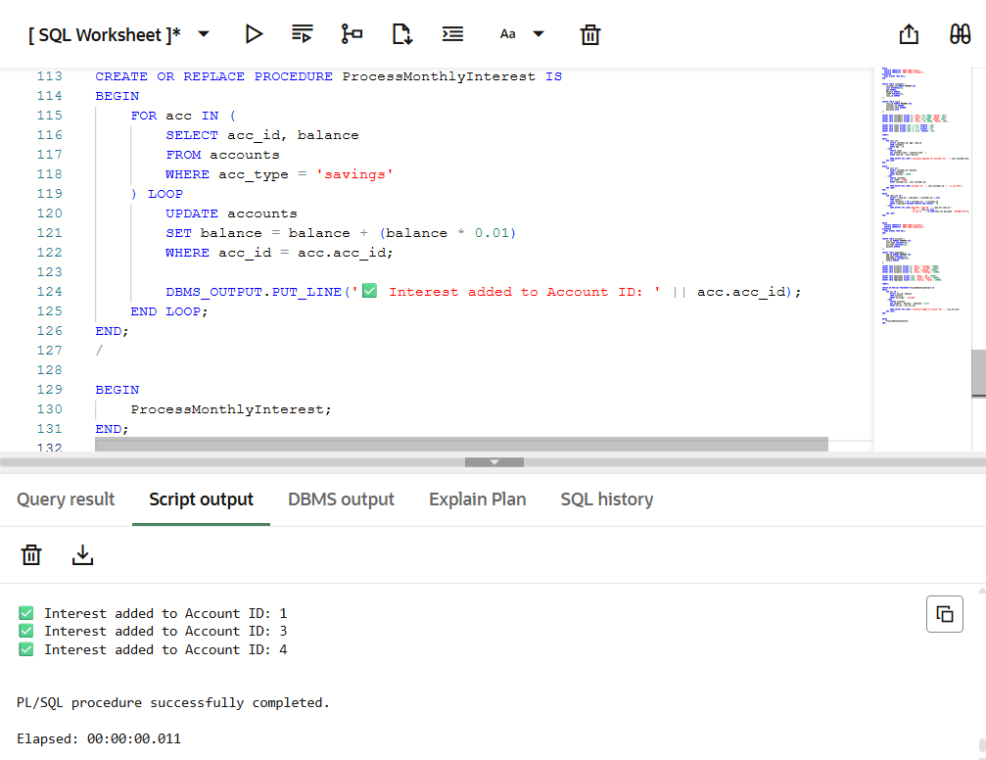

**Scenario 2:**

CREATE OR REPLACE PROCEDURE UpdateEmployeeBonus (

    dept_name IN VARCHAR2,

    bonus_pct IN NUMBER

) IS

BEGIN

    FOR emp IN (

        SELECT emp_id, salary FROM employees WHERE department = dept_name

    ) LOOP

        UPDATE employees

        SET salary = salary + (salary * bonus_pct / 100)

        WHERE emp_id = emp.emp_id;

        DBMS_OUTPUT.PUT_LINE('Bonus applied to Employee ID: ' || emp.emp_id);

    END LOOP;

END;

/

BEGIN

    UpdateEmployeeBonus('Sales', 10);

END;

/

**OUTPUT:**

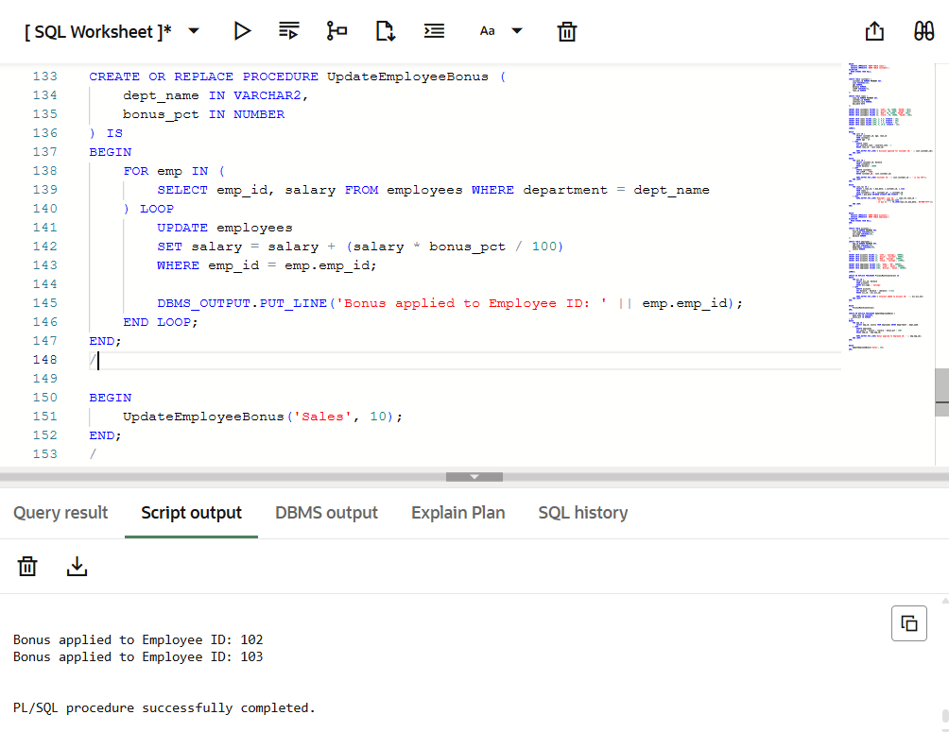

**Scenario 3:**

CREATE OR REPLACE PROCEDURE TransferFunds (

    from_acc IN NUMBER,

    to_acc IN NUMBER,

    amount IN NUMBER

) IS

    from_balance NUMBER;

BEGIN

    SELECT balance INTO from_balance FROM accounts WHERE acc_id = from_acc;

    IF from_balance >= amount THEN

        UPDATE accounts

        SET balance = balance - amount

        WHERE acc_id = from_acc;

        UPDATE accounts

        SET balance = balance + amount

        WHERE acc_id = to_acc;

        DBMS_OUTPUT.PUT_LINE(' Transfer of Rs.' || amount ||

                             ' from Account ' || from_acc ||

                             ' to Account ' || to_acc || ' completed.');

    ELSE

        DBMS_OUTPUT.PUT_LINE('Transfer failed: Insufficient balance in Account ' || from_acc);

    END IF;

END;

/

BEGIN

    TransferFunds(1, 2, 3000);

END;

/

**OUTPUT:**

